**United States Department of Agriculture National Agricultural Statistics Service**



**2020 California Almond** **Objective Measurement Report**

**Cooperating with the California Department of Food and Agriculture**

Pacific Regional Office · P.O. Box 1258 · Sacramento, CA 95812 · (916) 738-6600 [· www.nass.usda.gov/ca](http://www.nass.usda.gov/ca)

**Released: July 7, 2020 - 12:00 p.m. PDT**

**TABLE 1: JUNE OBJECTIVE MEASUREMENT SURVEY COUNTS; COMPARISON OF NUT ESTIMATES AND ORCHARDS SAMPLED BY REGION AND VARIETY, 2016-2020**

|  |  |  |  |  |  |  |  |  |  |  |
| --- | --- | --- | --- | --- | --- | --- | --- | --- | --- | --- |
| District and Variety | 2016 | | 2017 | | 2018 | | 2019 | | 2020 | |
| Nuts per tree | Orchards sampled | Nuts per tree | Orchards sampled | Nuts per tree | Orchards sampled | Nuts per tree | Orchards sampled | Nuts per tree | Orchards sampled |
| **ALL REGIONS** |  | |  | |  | |  | |  | |
| (All Varieties)  **BY REGION** 1/ | 6,159 873 | | 5,714 852 | | 5,677 853 | | 4,667 817 | | 5,645 909 | |
| North | 6,114 121 | | 5,583 118 | | 5,015 117 | | 4,401 103 | | 7,369 115 | |
| Central | 6,094 298 | | 5,704 293 | | 6,181 302 | | 4,739 297 | | 6,549 312 | |
| South  **BY VARIETY** | 6,213 454 | | 5,756 441 | | 5,506 434 | | 4,682 417 | | 4,648 482 | |
| Butte | 7,051 112 | | 6,574 97 | | 5,989 91 | | 5,261 78 | | 5,923 81 | |
| Carmel | 5,849 105 | | 5,456 95 | | 6,353 91 | | 4,865 83 | | 5,797 51 | |
| Independence | 2,868 7 | | 4,032 12 | | 4,762 38 | | 3,718 41 | | 3,948 80 | |
| Monterey | 5,739 136 | | 4,655 137 | | 5,362 138 | | 4,426 145 | | 4,719 166 | |
| Nonpareil | 5,583 343 | | 5,717 343 | | 4,924 333 | | 4,429 324 | | 5,621 358 | |
| Padre | 7,788 70 | | 7,168 65 | | 6,732 63 | | 4,928 56 | | 8,137 54 | |
| Other CA Types 2/ | 7,240 70 | | 5,944 74 | | 8,369 68 | | 6,204 57 | | 7,505 80 | |

**TABLE 2: WEIGHT, SIZE AND GRADE OF AVERAGE ALMOND SAMPLE, 2016-2020**

|  |  |  |  |  |  |  |  |  |  |  |  |  |
| --- | --- | --- | --- | --- | --- | --- | --- | --- | --- | --- | --- | --- |
| District and variety | Year | Kernel weight  (grams) | Kernel size (millimeters) | | |  | | Grade (percent of nuts) 1/ | | |  |  |
| Edible nuts | | Insect  damage | Shrivel | Natural gum | Blank | Other |
| Length | Width | Thickness | Singles | Doubles |
| **ALL REGIONS** | 2016 | 1.48 | 22.09 12.44 9.93 | | | 95.9 2.9 | | 2/ 1.1 2/ | | | 2/ | 2/ |
| (All Varieties) | 2017 | 1.57 | 22.50 12.83 10.40 | | | 92.2 6.2 | | 2/ 1.5 0.1 | | | 2/ | 2/ |
|  | 2018 | 1.54 | 21.32 12.79 10.37 | | | 90.9 7.9 | | 2/ 1.0 2/ | | | 2/ | 0.1 |
|  | 2019 | 1.54 | 22.89 12.86 9.93 | | | 92.7 6.0 | | 2/ 1.2 2/ | | | 2/ | 2/ |
| **BY REGION 3/**  **North** | **2020** | **1.51** | **21.79 12.60 10.12** | | | **95.5 3.0** | | **2/ 1.2 0.1** | | | **2/** | **0.2** |
|  |  |  | | |  | |  | | |  |  |
| 2016 | 1.51 | 22.67 13.19 10.02 | | | 97.2 1.2 | | 2/ 1.4 2/ | | | 2/ | 0.1 |
|  | 2017 | 1.69 | 23.85 13.59 10.46 | | | 88.3 9.1 | | 2/ 2.3 0.3 | | | 2/ | 2/ |
|  | 2018 | 1.61 | 20.91 13.26 10.45 | | | 91.6 7.4 | | 2/ 0.8 2/ | | | 2/ | 0.2 |
|  | 2019 | 1.56 | 23.44 13.42 9.70 | | | 89.8 8.8 | | 2/ 1.4 2/ | | | 2/ | 2/ |
| **Central** | **2020** | **1.51** | **21.62 12.88 9.92** | | | **94.5 4.0** | | **2/ 1.1 2/** | | | **2/** | **0.3** |
| 2016 | 1.56 | 22.54 12.63 10.14 | | | 96.6 2.8 | | 2/ 2/ 2/ | | | 2/ | 2/ |
|  | 2017 | 1.61 | 22.75 12.72 10.53 | | | 91.6 7.4 | | 2/ 0.9 0.1 | | | 2/ | 2/ |
|  | 2018 | 1.62 | 21.96 12.87 10.65 | | | 89.2 10.3 | | 2/ 0.5 | | | 2/ | 2/ |
|  | 2019 | 1.64 | 22.54 12.87 10.08 | | | 92.1 6.7 | | 2/ 1.0 0.1 | | | 2/ | 2/ |
| **South** | **2020** | **1.52** | **21.74 12.47 10.16** | | | **96.2 2.8** | | **2/ 0.8 0.2** | | | **2/** | **2/** |
| 2016 | 1.42 | 21.65 12.13 9.76 | | | 95.2 3.3 | | 2/ 1.4 0.1 | | | 2/ | 2/ |
|  | 2017 | 1.51 | 21.98 12.71 10.30 | | | 93.5 4.5 | | 2/ 1.7 0.1 | | | 2/ | 2/ |
|  | 2018 | 1.46 | 20.93 12.62 10.14 | | | 92.1 6.2 | | 2/ 1.5 2/ | | | 2/ | 0.1 |
|  | 2019 | 1.46 | 22.29 12.72 9.88 | | | 93.8 4.9 | | 2/ 1.2 2/ | | | 2/ | 2/ |
| **BY VARIETY**  **Butte** | **2020** | **1.50** | **21.90 12.61 10.15** | | | **95.1 2.8** | | **2/ 1.6 0.1** | | | **2/** | **0.3** |
|  |  |  | | |  | |  | | |  |  |
| 2016 | 1.20 | 18.93 11.76 9.84 | | | 96.1 2.6 | | 2/ 1.2 0.1 | | | 2/ | 2/ |
|  | 2017 | 1.25 | 19.14 11.89 10.43 | | | 89.3 9.6 | | 2/ 0.9 0.2 | | | 2/ | 2/ |
|  | 2018 | 1.19 | 17.97 11.97 10.09 | | | 92.9 6.0 | | 2/ 0.9 2/ | | | 2/ | 0.2 |
|  | 2019 | 1.18 | 19.46 11.89 9.64 | | | 92.9 6.0 | | 2/ 1.1 2/ | | | 2/ | 2/ |
| **Carmel** | **2020** | **1.22** | **18.37 11.84 10.00** | | | **94.6 4.2** | | **2/ 1.1 0.1** | | | **2/** | **2/** |
| 2016 | 1.51 | 23.08 12.07 9.86 | | | 96.0 3.0 | | 2/ 1.0 2/ | | | 2/ | 2/ |
|  | 2017 | 1.60 | 23.72 12.31 10.38 | | | 89.7 9.2 | | 2/ 1.0 0.1 | | | 2/ | 2/ |
|  | 2018 | 1.61 | 22.43 12.52 10.57 | | | 87.0 12.6 | | 2/ 0.4 2/ | | | 2/ | 2/ |
|  | 2019 | 1.60 | 23.99 12.43 10.02 | | | 89.8 9.0 | | 2/ 1.1 2/ | | | 2/ | 2/ |
| **Independence** | **2020** | **1.51** | **22.61 12.05 9.99** | | | **94.7 4.2** | | **2/ 0.8 0.3** | | | **2/** | **2/** |
| 2016 | 1.99 | 25.86 14.36 10.32 | | | 95.4 4.6 | | 2/ 2/ 2/ | | | 2/ | 2/ |
|  | 2017 | 1.92 | 25.00 13.92 10.74 | | | 92.1 4.7 | | 2/ 3.2 2/ | | | 2/ | 2/ |
|  | 2018 | 1.86 | 23.50 14.16 10.84 | | | 92.1 6.0 | | 2/ 1.7 0.2 | | | 2/ | 2/ |
|  | 2019 | 1.88 | 25.38 14.43 10.30 | | | 94.2 3.7 | | 2/ 1.7 2/ | | | 2/ | 0.3 |
| **Monterey** | **2020** | **1.85** | **24.95 14.11 10.38** | | | **96.6 1.1** | | **2/ 1.1 1.0** | | | **2/** | **0.1** |
| 2016 | 1.69 | 24.68 12.49 10.03 | | | 92.1 6.9 | | 2/ 0.8 0.1 | | | 2/ | 2/ |
|  | 2017 | 1.83 | 25.20 13.06 10.64 | | | 85.4 12.8 | | 2/ 1.3 0.5 | | | 2/ | 2/ |
|  | 2018 | 1.76 | 23.42 12.93 10.74 | | | 83.0 16.2 | | 2/ 0.8 2/ | | | 2/ | 2/ |
|  | 2019 | 1.69 | 24.77 12.84 10.15 | | | 86.3 12.7 | | 2/ 0.8 2/ | | | 2/ | 2/ |
| **Padre** | **2020** | **1.67** | **24.23 12.52 10.23** | | | **91.8 6.3** | | **2/ 1.2 0.2** | | | **2/** | **0.5** |
| 2016 | 1.14 | 18.47 11.42 9.86 | | | 96.7 1.7 | | 2/ 1.4 0.1 | | | 0.1 | 2/ |
|  | 2017 | 1.26 | 19.13 11.85 10.51 | | | 94.0 4.2 | | 2/ 1.7 2/ | | | 2/ | 2/ |
|  | 2018 | 1.15 | 17.54 11.72 10.16 | | | 94.0 4.4 | | 2/ 1.3 2/ | | | 2/ | 0.4 |
|  | 2019 | 1.23 | 19.42 11.97 9.85 | | | 97.2 2.0 | | 2/ 0.6 0.1 | | | 2/ | 2/ |
| **Nonpareil** | **2020** | **1.25** | **18.41 11.66 10.17** | | | **97.6 1.1** | | **2/ 1.2 2/** | | | **2/** | **2/** |
| 2016 | 1.65 | 23.36 13.34 10.01 | | | 97.1 1.7 | | 2/ 1.1 2/ | | | 2/ | 2/ |
|  | 2017 | 1.70 | 23.50 13.60 10.32 | | | 95.1 3.0 | | 2/ 1.8 0.1 | | | 2/ | 2/ |
|  | 2018 | 1.70 | 22.36 13.66 10.37 | | | 94.0 4.8 | | 2/ 1.2 2/ | | | 2/ | 2/ |
|  | 2019 | 1.63 | 23.46 13.48 9.85 | | | 95.4 3.2 | | 2/1.4 2/ | | | 2/ | 2/ |
| **Other CA Types4/** | **2020** | **1.60** | **22.29 13.26 10.14** | | | **96.4 1.9** | | **2/ 1.5 2/** | | | **2/** | **0.2** |
| 2016 | 1.25 | 20.62 11.43 9.62 | | | 96.9 1.8 | | 2/ 1.3 2/ | | | 2/ | 2/ |
|  | 2017 | 1.33 | 20.85 12.01 10.19 | | | 94.3 4.2 | | 2/ 1.2 0.2 | | | 2/ | 2/ |
|  | 2018 | 1.26 | 19.62 11.61 10.74 | | | 92.0 6.7 | | 2/ 1.0 2/ | | | 2/ | 0.1 |
|  | 2019 | 1.36 | 21.47 12.14 9.95 | | | 93.0 5.8 | | 2/ 1.1 2/ | | | 2/ | 0.1 |
|  | **2020** | **1.22** | **19.88 11.32 9.79** | | | **97.1 2.0** | | **2/ 0.6 2/** | | | **2/** | **0.3** |

# 1/ Percentages may not add to 100 due to rounding.

# 2/ Not shown if less than 0.07 percent.

# 3/ North includes Butte, Colusa, Glenn, Solano, Sutter, Tehama, Yolo, and Yuba counties.

# Central includes Merced, San Joaquin, and Stanislaus counties. South includes Fresno, Kern, Kings, Madera, and Tulare counties.

# 4/ For survey purposes, the California classification includes the following varieties: Aldrich, Ballico, Davey, Fritz, Harvey, Le Grand, Mono, Norman,

# Price Cluster, Ruby, Sonora, Tokyo and Yosemite.

**2020 California Almond Objective Measurement Report (July 7, 2020)** USDA, National Agricultural Statistics Service, Pacific Region

**Page 2 of 5**

**ALMONDS**

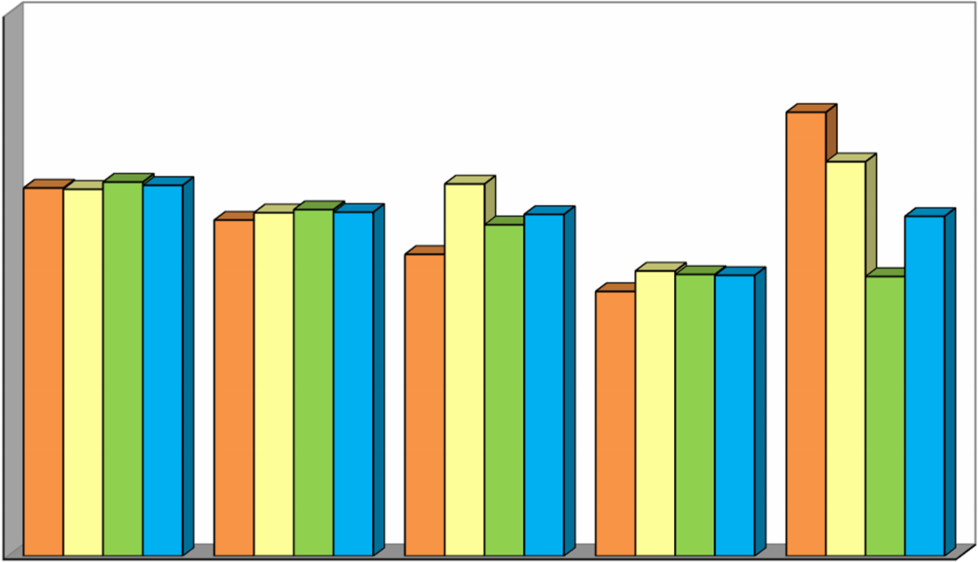

**0**

**2,000**

**4,000**

**6,000**

**8,000**

**6**

**,**

**114**

**5**

**,**

**583**

**5**

**,**

**015**

**4**

**,**

**401**

**7**

**,**

**369**

**6,094**

**5,704**

**6,181**

**4,739**

**6,549**

**6,213**

**5,756**

**5,506**

**4,682**

**4,648**

**6,159**

**5,714**

**5,677**

**4,667**

**5,645**

**Nuts per Tree, by Region**

North

Central

South

State

**2016 2017 2018 2019 2020**

**ALMONDS BY VARIETY**

**2020 California Almond Objective Measurement Report (July 7, 2020)** USDA, National Agricultural Statistics Service, Pacific Region

|  |  |  |
| --- | --- | --- |
|  |  |  |
| **NONPAREIL TYPE** |  | **INDEPENDENCE TYPE** |

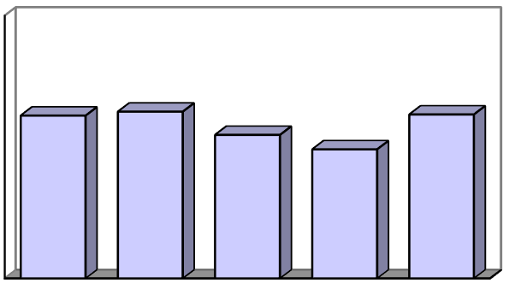

**0**

**2,000**

**4,000**

**6,000**

**8,000**

**2016**

**2017**

**2018**

**2019**

**2020**

**5,583**

**5,717**

**4,924**

**4,429**

**5,621**

**Nuts per Tree**

**0**

**2,000**

**4,000**

**6,000**

**8,000**

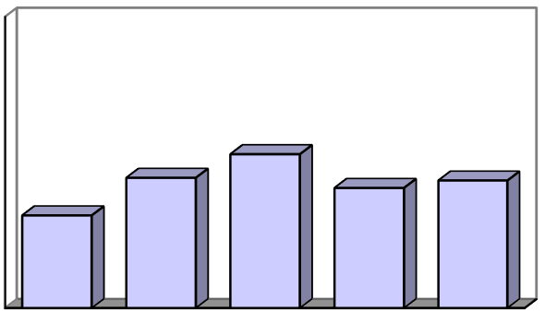

**2016**

**2017**

**2018**

**2019**

**2020**

**2,868**

**4,032**

**4,762**

**3,718**

**3,948**

**Nuts per Tree**

|  |  |  |  |
| --- | --- | --- | --- |
|  |  |  |  |
| **MONTEREY TYPE** |  | **BUTTE TYPE** |  |

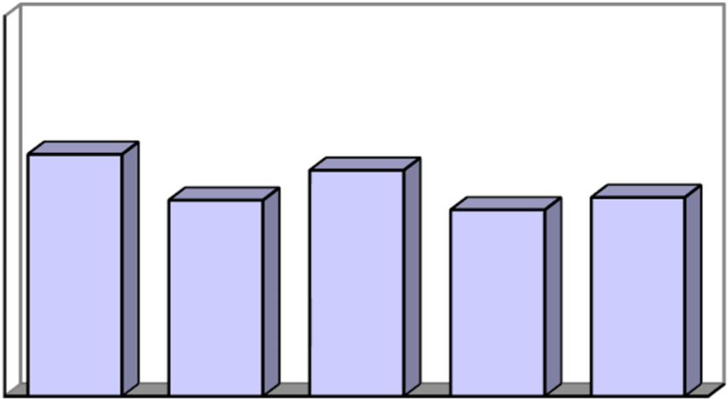

**0**

**2,000**

**4,000**

**6,000**

**8,000**

**2016**

**2017**

**2018**

**2019**

**2020**

**5,739**

**4,655**

**5,362**

**4,426**

**4,719**

**Nuts per Tree**

**0**

**2,000**

**4,000**

**6,000**

**8,000**

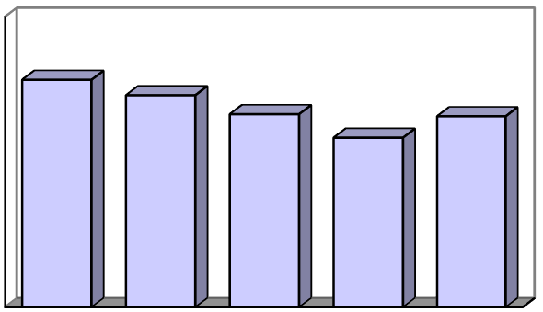

**2016**

**2017**

**2018**

**2019**

**2020**

**7,051**

**6,574**

**5,989**

**5,261**

**5,923**

**Nuts per Tree**

**Page 3 of 5**

**TABLE 3: CALIFORNIA ALMOND ACREAGE, PRODUCTION AND TREES PER ACRE, 1986-2020**

|  |  |  |  |  |  |  |  |
| --- | --- | --- | --- | --- | --- | --- | --- |
| Year | Bearing acres 1/ | Trees per acre | Total Meat Production | |  | Price per lb. | Value of production |
| Metric Tons  2/ | Million lbs. | Lbs. per acre | dollars | 1,000 dollars |
| 1986 | 416,000 | 84.5 | 113,000 250 | | 601 | 1.92 | 461,568 |
| 1987 | 417,000 | 84.0 | 299,000 660 | | 1,580 | 1.00 | 648,000 |
| 1988 | 419,000 | 86.3 | 268,000 590 | | 1,410 | 1.05 | 600,075 |
| 1989 | 411,000 | 87.3 | 222,000 490 | | 1,190 | 1.02 | 480,930 |
| 1990 | 411,000 | 88.4 | 299,000 660 | | 1,610 | 0.93 | 597,990 |
| 1991 | 405,000 | 89.6 | 222,000 490 | | 1,210 | 1.19 | 564,179 |
| 1992 | 401,000 | 90.5 | 249,000 548 | | 1,370 | 1.30 | 691,340 |
| 1993 | 413,000 | 92.0 | 222,000 490 | | 1,190 | 1.94 | 930,618 |
| 1994 | 433,000 | 92.6 | 333,000 735 | | 1,700 | 1.34 | 965,202 |
| 1995 | 418,000 | 93.7 | 168,000 370 | | 885 | 2.48 | 880,896 |
| 1996 | 428,000 | 94.4 | 231,000 510 | | 1,190 | 2.08 | 1,018,368 |
| 1997 | 442,000 | 95.5 | 344,000 759 | | 1,720 | 1.56 | 1,160,640 |
| 1998 | 460,000 | 96.3 | 236,000 520 | | 1,130 | 1.41 | 703,590 |
| 1999 | 485,000 | 97.3 | 378,000 833 | | 1,720 | 0.86 | 687,742 |
| 2000 | 510,000 | 99.0 | 319,000 703 | | 1,380 | 0.97 | 666,487 |
| 2001 | 530,000 | 101.0 | 376,000 830 | | 1,570 | 0.91 | 740,012 |
| 2002 | 545,000 | 101.0 | 494,000 1,090 | | 2,000 | 1.11 | 1,200,687 |
| 2003 | 550,000 | 103.0 | 472,000 1,040 | | 1,890 | 1.57 | 1,600,144 |
| 2004 | 570,000 | 103.0 | 456,000 1,005 | | 1,760 | 2.21 | 2,189,005 |
| 2005 | 590,000 | 104.0 | 415,000 915 | | 1,550 | 2.81 | 2,525,909 |
| 2006 | 610,000 | 105.0 | 508,000 1,120 | | 1,840 | 2.06 | 2,258,790 |
| 2007 | 640,000 | 105.0 | 630,000 1,390 | | 2,170 | 1.75 | 2,401,875 |
| 2008 | 710,000 | 107.0 | 739,000 1,630 | | 2,300 | 1.45 | 2,343,200 |
| 2009 | 750,000 | 108.0 | 640,000 1,410 | | 1,880 | 1.65 | 2,293,500 |
| 2010 | 770,000 | 108.0 | 744,000 1,640 | | 2,130 | 1.79 | 2,903,380 |
| 2011 | 800,000 | 111.0 | 921,000 2,030 | | 2,540 | 1.99 | 4,007,860 |
| 2012 | 820,000 | 112.0 | 857,000 1,890 | | 2,300 | 2.58 | 4,816,860 |
| 2013 | 880,000 | 112.0 | 912,000 2,010 | | 2,280 | 3.21 | 6,384,690 |
| 2014 | 930,000 | 114.0 | 848,000 1,870 | | 2,010 | 4.00 | 7,388,000 |
| 2015 | 950,000 | 114.0 | 862,000 1,900 | | 2,000 | 3.13 | 5,868,750 |
| 2016 | 970,000 | 116.0 | 971,000 2,140 | | 2,210 | 2.39 | 5,052,460 |
| 2017 | 1,030,000 | 117.0 | 1,030,000 2,270 | | 2,200 | 2.53 | 5,603,950 |
| 2018 | 1,090,000 | 119.0 | 1,034,000 2,280 | | 2,090 | 2.50 | 5,602,500 |
| 2019 | 1,180,000 | 122.0 | 1,157,000 2,550 | | 2,160 | 2.43 | 6,094,440 |
| 20203/ 4/ | 1,260,000 | 122.0 | 1,361,000 3,000 | | 2,380 | --- | --- |

# 1/ Bearing acreage is defined as plantings four years and older

# 2/ Rounded to nearest thousand, metric ton = 2,204.62 pounds.

# 3/ Price and value will be available in the annual Noncitrus Fruits & Nuts publication, released in May 2021. 4/ Preliminary estimate of bearing acres. ─ Not available.

**Page 4 of 5 2020 California Almond Objective Measurement Report (July 7, 2020)**

USDA, National Agricultural Statistics Service, Pacific Region

2020 ALMOND SAMPLE DISTRIBUTION

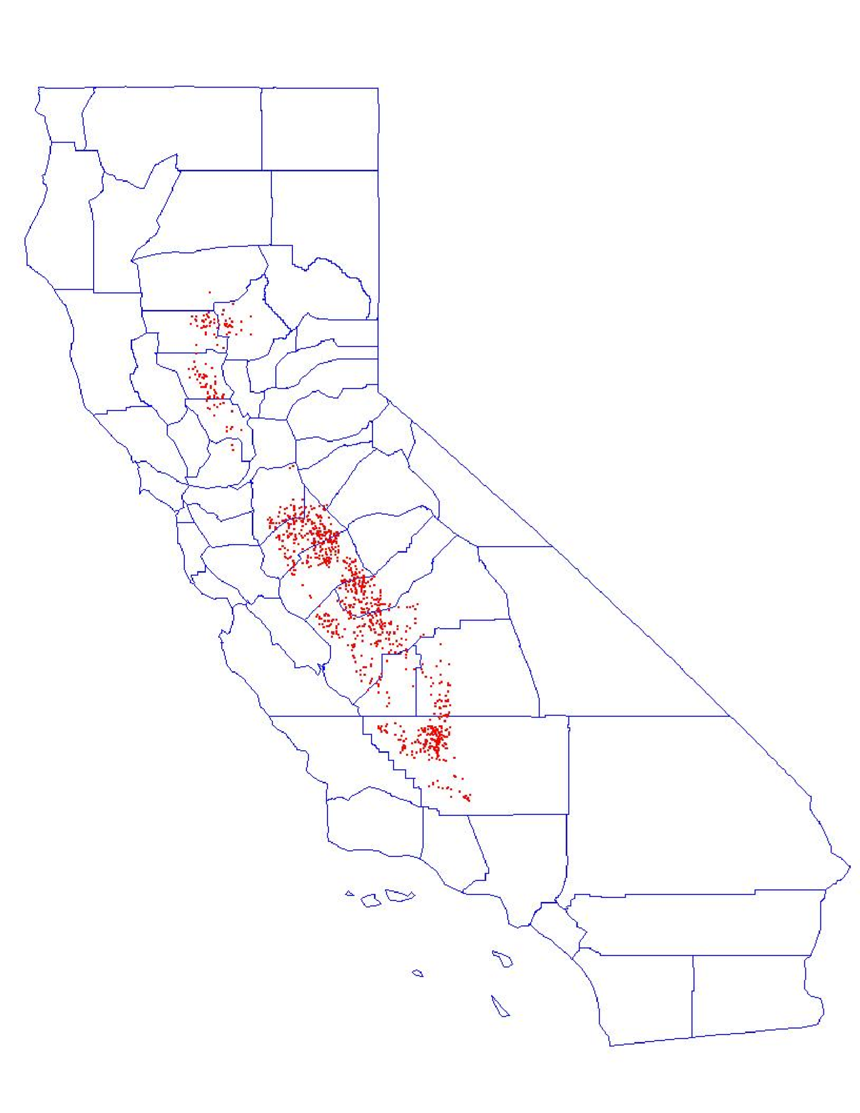

**Page 5 of 5 2020 California Almond Objective Measurement Report (July 7, 2020)**

USDA, National Agricultural Statistics Service, Pacific Region